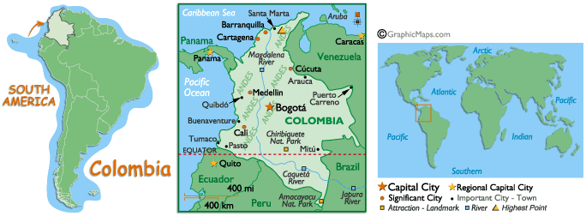

Last month, Spanish 8 students took a week-long fantasy trip to the coast of Colombia.

On Monday, we took an Avianca flight, saw an in-flight movie about Colombia and had our passports stamped.

On Tuesday, we arrived in Cartagena, where we tried tropical fruit drinks made from lulo, maracuyá (passion fruit) and mora (Andean blackberry).

On Wednesday, we went to the beach in Barranquilla, where we listened to vallenatos (typical music) and ate coconut ices.

On Thursday, we visited a craft stand in Santa Marta where molas (indigenous crafts) were on display.

On Friday, students tried their hand at making their own molas. What you see on display in the cabinet is the handiwork of our 8th grade students.
¡Qué viva Colombia!

