Classroom Instruction That Works:

9 Strategies for Successful Student Learning

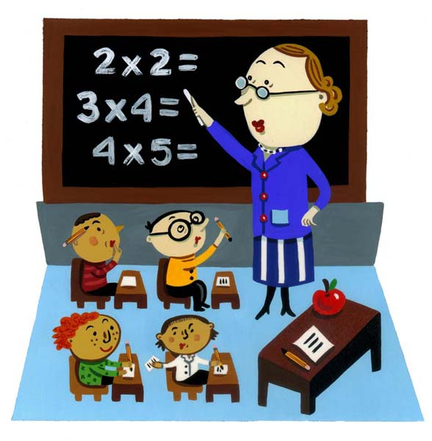

Presenter: Dr. Lori Langer de Ramirez
Chair, ESL and World Language Department
Herricks Public Schools, New York
lori@miscositas.com | www.miscositas.com

Marzano’s 9 Strategies:
1. Identifying similarities and differences
2. Summarizing and note taking
3. Reinforcing effort and providing recognition
4. Homework and practice
5. Nonlinguistic representations
6. Cooperative learning
7. Setting objectives and providing feedback
8. Generating and testing hypotheses
9. Cues, questions, and advance organizers

Overview of each strategy (from: http://www.middleweb.com/MWLresources/marzchat1.html)

1. Identifying Similarities and Differences
The ability to break a concept into its similar and dissimilar characteristics allows students to understand (and often solve) complex problems by analyzing them in a more simple way. Teachers can either directly present similarities and differences, accompanied by deep discussion and inquiry, or simply ask students to identify similarities and differences on their own. While teacher-directed activities focus on identifying specific items, student-directed activities encourage variation and broaden understanding, research shows. Research also notes that graphic forms are a good way to represent similarities and differences.

Applications:
* Use Venn diagrams or charts to compare and classify items.
* Engage students in comparing, classifying, and creating metaphors and analogies.
2. Summarizing and Note Taking
These skills promote greater comprehension by asking students to analyze a subject to expose what's essential and then put it in their own words. According to research, this requires substituting, deleting, and keeping some things and having an awareness of the basic structure of the information presented.

Applications:
* Provide a set of rules for creating a summary.
* When summarizing, ask students to question what is unclear, clarify those questions, and then predict what will happen next in the text.
Research shows that taking more notes is better than fewer notes, though verbatim note taking is ineffective because it does not allow time to process the information. Teachers should encourage and give time for review and revision of notes; notes can be the best study guides for tests.

Applications:
* Use teacher-prepared notes.
* Stick to a consistent format for notes, although students can refine the notes as necessary.
3. Reinforcing Effort and Providing Recognition
Effort and recognition speak to the attitudes and beliefs of students, and teachers must show the connection between effort and achievement. Research shows that although not all students realize the importance of effort, they can learn to change their beliefs to emphasize effort.

Applications:
* Share stories about people who succeeded by not giving up.
* Have students keep a log of their weekly efforts and achievements, reflect on it periodically, and even mathematically analyze the data.
According to research, recognition is most effective if it is contingent on the achievement of a certain standard. Also, symbolic recognition works better than tangible rewards.

Applications:
* Find ways to personalize recognition. Give awards for individual accomplishments.
* "Pause, Prompt, Praise." If a student is struggling, pause to discuss the problem, then prompt with specific suggestions to help her improve. If the student's performance improves as a result, offer praise.
4. Homework and Practice
Homework provides students with the opportunity to extend their learning outside the classroom. However, research shows that the amount of homework assigned should vary by grade level and that parent involvement should be minimal. Teachers should explain the purpose of homework to both the student and the parent or guardian, and teachers should try to give feedback on all homework assigned.

Applications:
* Establish a homework policy with advice-such as keeping a consistent schedule, setting, and time limit-that parents and students may not have considered.
* Tell students if homework is for practice or preparation for upcoming units.
* Maximize the effectiveness of feedback by varying the way it is delivered.
Research shows that students should adapt skills while they're learning them. Speed and accuracy are key indicators of the effectiveness of practice.

Applications:
* Assign timed quizzes for homework and have students report on their speed and accuracy.
* Focus practice on difficult concepts and set aside time to accommodate practice periods.
5. Nonlinguistic Representations
According to research, knowledge is stored in two forms: linguistic and visual. The more students use both forms in the classroom, the more opportunity they have to achieve. Recently, use of nonlinguistic representation has proven to not only stimulate but also increase brain activity.

Applications:
* Incorporate words and images using symbols to represent relationships.
* Use physical models and physical movement to represent information.

6. Cooperative Learning
Research shows that organizing students into cooperative groups yields a positive effect on overall learning. When applying cooperative learning strategies, keep groups small and don't overuse this strategy-be systematic and consistent in your approach.

Applications:
* When grouping students, consider a variety of criteria, such as common experiences or interests.
* Vary group sizes and objectives.
* Design group work around the core components of cooperative learning-positive interdependence, group processing, and appropriate use of social skills, face-to-face interaction, and individual and group accountability.
7. Setting Objectives and Providing Feedback
Setting objectives can provide students with a direction for their learning. Goals should not be too specific; they should be easily adaptable to students' own objectives.

Applications:
* Set a core goal for a unit, and then encourage students to personalize that goal by identifying areas of interest to them. Questions like "I want to know" and "I want to know more about . . ." get students thinking about their interests and actively involved in the goal-setting process.
* Use contracts to outline the specific goals that students must attain and the grade they will receive if they meet those goals.
Research shows that feedback generally produces positive results. Teachers can never give too much; however, they should manage the form that feedback takes.

Applications:
* Make sure feedback is corrective in nature; tell students how they did in relation to specific levels of knowledge. Rubrics are a great way to do this.
* Keep feedback timely and specific.
* Encourage students to lead feedback sessions.
8. Generating and Testing Hypotheses
Research shows that a deductive approach (using a general rule to make a prediction) to this strategy works best. Whether a hypothesis is induced or deduced, students should clearly explain their hypotheses and conclusions.

Applications:
* Ask students to predict what would happen if an aspect of a familiar system, such as the government or transportation, were changed.
* Ask students to build something using limited resources. This task generates questions and hypotheses about what may or may not work.
9. Cues, Questions, and Advance Organizers
Cues, questions, and advance organizers help students use what they already know about a topic to enhance further learning. Research shows that these tools should be highly analytical, should focus on what is important, and are most effective when presented before a learning experience.

Applications:
* Pause briefly after asking a question. Doing so will increase the depth of your students' answers.
* Vary the style of advance organizer used: Tell a story, skim a text, or create a graphic image. There are many ways to expose students to information before they "learn" it.

Comparisons Chart: What items do you want to compare? What characteristics do you want to compare? How are the items similar and different based on the characteristics? Place an 'X' in the box to indicate if an item possesses that characteristic. How are they alike? How are they different?
Characteristics

Things
To be
Compared

Venn Diagram: Choose two items that are similar and different in your subject area. Compare and contrast their characteristics in the Venn Diagram below.
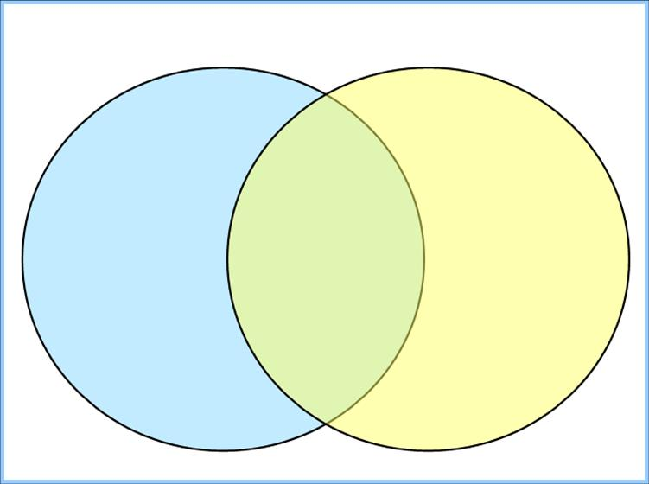
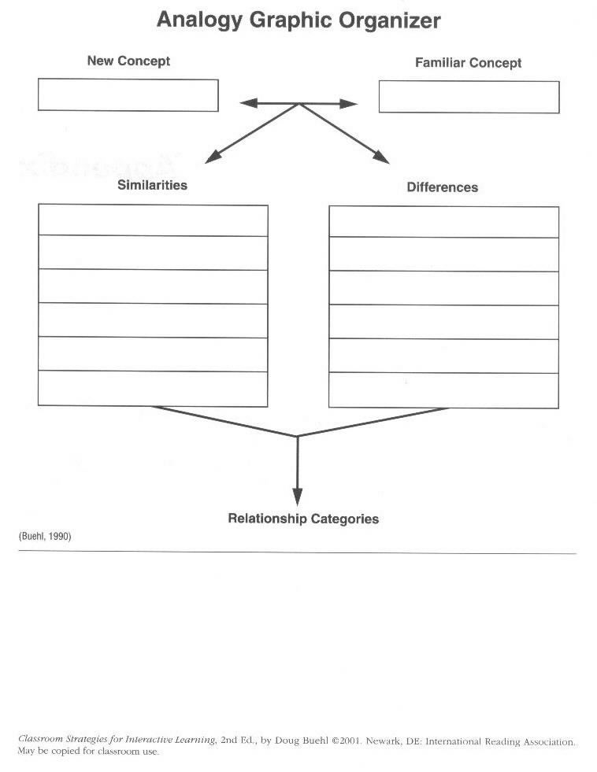
http://education.csm.edu/students/bpickett/Teaching%20Reading/AnGrOrg.jpg

Strategies for Reflection and Summarizing Learning
(Ideas from Bruce Welman, Carolyn Chapman, and Laurie Kagan, accessed at: http://schoolweb.dysart.org/.../g_00004_200908091648_Summary%20Strategies.docx)

Think, Write, Pair, Share or Think, Write, Trio, Share
“Write your idea on your card, find a partner (or two) and share your idea.”
When you ask students to share an idea – Give them a card to think and WRITE what they are thinking.
Then everyone has the opportunity to come to the group with an idea. This gives those who tend to be more reflective a chance to think!

Say Something
Ask students to choose a partner. Read silently to the designated stopping point. When each partner is ready, stop and “say something.” Continue this process until you have completed the selection. You may want to ask students to record the most important ideas.

One Word Summary
“Craft a one word summary of this class/lesson or topic. Be prepared to share your word – the what and why you chose it.”

A to Z
Ask students to list words or phrases to review their learning trying to fill in a blank for each letter of the alphabet. After individual time is given, ask students to find other students to help them fill in the blanks or add to it as the unit continues.

Round the Room and Back Again
This is an energetic way to activate your student’s knowledge of a topic and assess their understanding of what you have taught. It works well as a transition point in a lesson. Have each student take out a sheet of paper and answer the question initiated by the teacher. (e.g. Name one idea or list a fact(s). . .

Students then set aside their writing materials and on the teacher's direction move around the room sharing their ideas/facts and listening to the ideas of others. The challenge is to rely only on auditory memory.

Time is called when people's memory banks fill up (seven items plus or minus two). Students then return to their seats and write down as many ideas/facts as they can recall. Table groups then pool their ideas and extend their lists. Large group sharing can also be part of this exercise.

Squaring Off
This activity can give you a quick assessment of where your class is as a whole in their learning. Students should be reminded that this activity is to inform your instruction.

Place a card in each corner of the room with one of the following words or phrases:
Rarely ever Sometimes Often I have it!
Dirt road Paved road Highway Yellow brick road

Tell students to go to the corner of the room that most closely matches their place for their own personal learning journey. Ask them to discuss what they know about the topic or even and why they chose to go there.

Strategies for Reflection and Summarizing Learning

Individual Activities for Formative Assessment
(Ideas from Bruce Welman, Carolyn Chapman, and Laurie Kagan, accessed at: http://schoolweb.dysart.org/.../g_00004_200908091648_Summary%20Strategies.docx)

3 – 2 – 1
Ask students to write:
3 - key ideas they think are most important
2 - things they need to study or learn more about
1 - question they have

Donuts
Draw a donut shape.
- On the inside, write “I know. . .”
- On the outside, write “I still need time to keep learning. . .”

Here’s What, So What, Now What
This is a great way to help students summarize a reading, a news article, and generate a discussion of information to help you plan for instruction. Ask students to write about their thoughts and share with another person or group:

Here’s What: Describe one very important concept/skills that you learned during this lesson.
So What: How can you practice or use this concept/skill so you will know you understand/remember it.
Now What: How can you use this concept/skill to help you become a better reader, writer, problem solver?

Comfort Zones
Ask students to reflect/summarize their individual learning thus far; create two lists: one labeled Comfort Zone, the other labeled Stretch.

Comfort Zone Stretch

Signals
This is a way to ask students for frequent individual input on how your lesson is going. It is recommended that students hold their signals close to their chest so it is easy for you to “read” your class.

What’s the Question?
This activity will give students an opportunity to inform you about their learning as a higher level thinking activity. Give the students “the answer” and they must come up with the question. This is similar to a jeopardy game format. An example might be:
A simile
What is a . . .comparison that uses “like” or “as”.

Tag Toss
Ask students to make name tags they keep in an envelope. At the end of a lesson or at a transition time, ask students to give you feedback about your instruction using one response. You may wish to sort name tags by colors to quickly assess the class learning as a whole. Ideas for cards:
I “got it”!
I need more help.
I need more time to practice.
My question is. . .

Exit Cards
Ask students to write their ideas as a one sentence summary of a lesson. They must give a card to you after a lesson to help you plan for the next day’s instruction and then you may decide to send the cards home to reinforce their learning for the day.
Some “starters” may include:
Today I learned . . . Tomorrow I need . . .
The first thing that I will share with my parents is . . .
A theme song for our work today would be . . .
The most important thing I learned today is . . . and example of this is. . .

In my subject area,
I can provide recognition by…

I can reinforce
effort by…

Effort and Achievement RUBRIC
(rubric taken from A Handbook for Classroom Instruction That Works, Marzano, p. 99-100)

Effort Rubric
4 I worked on the task until it was completed. I pushed myself to continue working on the task even when difficulties arose or a solution was not immediately evident. I viewed difficulties that arose as opportunities to strengthen my understanding.

3 I worked on the task until it was completed. I pushed myself to continue working on the task even when difficulties arose or a solution was not immediately evident.

2 I put some effort into the task, but I stopped working when difficulties arose.

1 I put very little effort into the task.

Achievement Rubric
4 I exceeded the objectives of the task or lesson.

3 I met the objectives of the task or lesson.

2 I met a few of the objectives of the task or lesson, but did not meet others.

1 I did not meet the objectives of the task or lesson.

Effort and Achievement Chart |  | Student:
Date: | Assignment: | Effort: | Achievement:

ONE HUNDRED WAYS TO PRAISE
Be free with praise for even minor successes; it will encourage larger successes. Be careful, however, never to be phony and praise when it isn’t deserved; you will lose your credibility and the value of future praise.

Fantastic!
That’s really nice.
That’s clever.
You’re right on target.
Thank you.
Wow!
That’s great!
Very creative.
Very interesting
I like the way you’re working.
Good thinking.
That’s an interesting way to look at it.
It’s a please to teach you.
Now you’ve figured it out.
Keep up the good work.
You’ve made my day.
Perfect!
You’re on the ball today.
This is something special.
Everyone’s working so hard.
That’s quite an improvement.
Much better.
Keep it up.
That’s the right answer.
Exactly right!
You’re on the right track now.
This is quite an accomplishment.
I like how you’ve tackled this assignment.
That’s coming along nicely.
I like the way you have settled down to work.
You’ve shown a lot of patience with this.
I noticed that you got right down to work.
You’ve really been paying attention.
It looks like you’ve put a lot of work into this.
You’ve put in a full day today.
This is prize-winning work.
An A-1 paper!
I like your style.
Pulitzer-prize-winner in training.
Your work has so much personality.
That’s very perceptive.
This is a moving scene.
Your remark shows a lot of sensitivity.
This really has flair.
Clear, concise, and complete!
A well-developed theme.
You are really in touch with the feelings here.
This piece has pizzazz.
A splendid job!
You’re right on the mark.
Good reasoning.
Very fine work.
You really scored here.
Outstanding.
This is a winner.
You’re at the top of the class.
Super!
Superior work.
Great going!
Where have you been hiding all this talent?
I knew you could do it.
You’re really moving along.
Good job.
What neat work!
You really outdid yourself today.
That’s a good point.
That’s a very good observation.
That’s certainly a neat way of looking at it.
This kind of work pleases me very much.
Congratulations! You got _____correct today.
That’s right. Good for you!
Terrific!
I bet your parents will be proud of you.
That’s an interesting point of view.
You’re really doing well.
You’ve got it now.
Nice going.
You make it all look so easy.
This shows you’ve been thinking.
You’re becoming an expert at this.
This gets a four-star rating.
You’re the one

From The Reading Teacher’s Book of Lists, 1993, Accessed online at: http://sitemaker.umich.edu/detroit.initiative/100_ways_to_praise

Sample Homework Policy (from Miami, Dade County Florida; accessed online at: http://schoolsites.schoolworld.com/schools/MiamiDadeNW/academics.cfm?subpage=212709)
Regular, purposeful homework is an essential part of a student's education. Homework is an integral factor in fostering the academic achievement of students and in extending school activities into the home and the community. Regular homework provides opportunities for developmental practice, drill, the application of skills already learned, the development of independent study skills, enrichment activities, and self-discipline. Homework should provide reinforcement and extension of class instruction, and should serve as a basis for further study and preparation for future class assignments.
Student's Responsibilities
- Completing assigned homework as directed and in the spirit in which it was assigned.
- Returning homework to the teacher by the designated time.
- Submitting homework assignments that reflect careful attention to detail and quality of work.
- Devoting a minimum of 30 minutes each day to reading as an additional part of homework.

Parents' Responsibilities
While it is understood that parents are not responsible for providing a great deal of assistance to their child in completing homework, parents promote good study habits. Parents' responsibilities include:
- Providing an environment conducive to study
- Providing continued interest and concern for the child's successful performance in school, through, encouraging and supporting the child in his/her performance of homework assigned.
- Indicating an interest in assignments and assisting, if possible, when requested by the child, but not to include performing the work for the child.
- Supporting the school in regard to the child being assigned homework
- Requesting assignments for the child when short-term absences are involved
- Assuring that the child reads for at least 30 minutes each day in addition to other homework.

What is your homework policy?

Nonlinguistic Representations

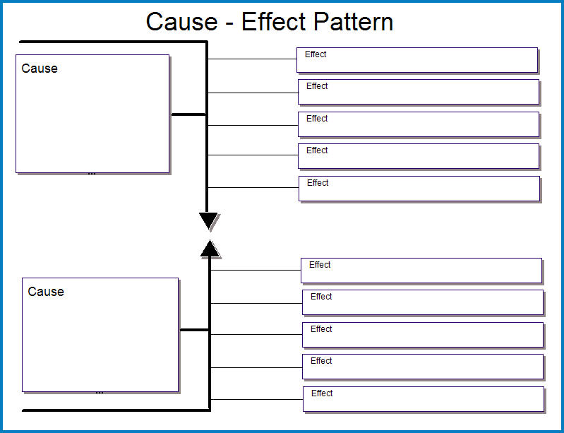

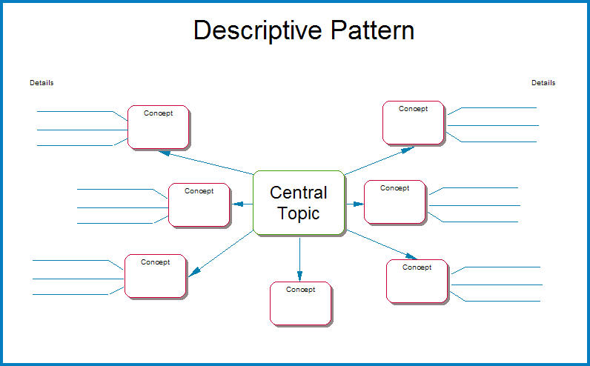
http://gets.gc.k12.va.us/VSTE/2008/5nonlinguistic.htm
What are some nonlinguistic activities that connect to your subject area?
Making physical models
Generating mental pictures

Creating graphic representations through organizers
Drawing pictures and pictographs

Engaging in kinesthetic activities

5 Elements of Cooperative Learning
(adapted from: http://edtech.kennesaw.edu/intech/cooperativelearning.htm)

1. Positive Interdependence (sink or swim together)  - Each group member's efforts are required and indispensable for group success  - Each group member has a unique contribution to make to the joint effort because of his or her resources and/or role and task responsibilities | 
2. Face-to-Face Interaction (promote each other's success)  - Orally explaining how to solve problems  - Teaching one's knowledge to other  - Checking for understanding  - Discussing concepts being learned  - Connecting present with past learning | 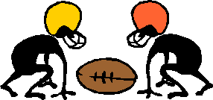
3. Individual & Group Accountability (no hitchhiking!)  - Keeping the size of the group small. The smaller the group, the greater the individual accountability.  - Giving an individual test to each student.  - Randomly examining students orally by calling on one student to present his or her group's work to the teacher (in the presence of the group) or to the class.  - Observing each group and recording the frequency with which each member-contributes to the group's work.  - Assigning one student the role of checker. The checker asks other group members to explain the reasoning and rationale underlying group answers.  - Having students teach what they learned to someone else. | 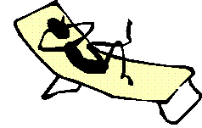
4. Interpersonal & Small-Group Skills  Social skills must be taught:  - Leadership  - Decision-making  - Trust-building  - Communication  - Conflict-management skills |  | 
5. Group Processing  Group members discuss how well they are achieving their goals and maintaining effective working relationships.  - Describe what member actions are helpful and not helpful  - Make decisions about what behaviors to continue or change |  | 
Your Cooperative Learning Activities

Partner #1 should share with the group some Cooperative Learning activities that you have used/or would like to use in your subject area.

Partner #2 should take notes.

Using the notes, Partner #3 should tell a member from another group about the Cooperative Learning activities that were shared.

Sample Book Report Project Rubric
(accessed online at: http://gets.gc.k12.va.us/VSTE/2008/images/objfeedbk/brrubric.jpg)

 | Look Fors | WOW!  3 | O.K.  2 | Not Yet  1
CONTENT | Title / Author | Includes title and author. | Includes one element, either title or author. | Does not include either element.
CONTENT | Main Characters / Setting | Includes main characters and setting. | Includes one element, characters or setting. | Does not include main characters or setting.
CONTENT | Summary | Gives beginning, middle, and ending of the story and tells all main ideas. Includes problem and how it is solved. | Two key elements are missing. | Three or more key elements are missing.
CONTENT | Opinion | States opinion and gives a reason. | States opinion but does not give a reason. | Does not state opinion.
PRESENTATION | Eye Contact | Looks at audience often during the presentation. | Some eye contact. (At least 2 times.) | No eye contact.
PRESENTATION | Audibility | Spoke clearly and could be heard throughout room during entire presentation. | Uses clear and loud voice at times during the presentation. | Monotone, speaks unclearly and low.
PRESENTATION | Speed | Uses a rate of speaking that is appropriate. | Speaking too fast or too slow during part of presentation. | Speaking too fast or too slow during entire presentation.
PRESENTATION | Enthusiasm | Animated and excited about project. | Somewhat animated and excited about project. | Not animated or excited about project at all.
PROJECT | Choice of Project | Type of project chosen blends well with presentation. |  | Type of project chosen does not blend well with presentation.
PROJECT | Creativity / Attractiveness | Eye-catching. Great effort shown. | Visible effort shown. | No effort shown.
 |  |  | Score: | Grade:
 |  |  | Name:
Guidelines for Rubric Development
(accessed online at: http://edweb.sdsu.edu/triton/july/rubrics/Rubric_Guidelines.html)

Steps in Rubric Development
- Determine learning outcomes
- Keep it short and simple (Include 4 - 15 items; use brief statements or phrases)
- Each rubric item should focus on a different skill
- Focus on how students develop and express their learning
- Evaluate only measureable criteria
- Ideally, the entire rubric should fit on one sheet of paper
- Reevaluate the rubric (Did it work? Was it sufficiently detailed?)

Terms to use in measuring range/scoring levels
- Needs Improvement...Satisfactory...Good...Exemplary
- Beginning...Developing...Accomplished...Exemplary
- Needs work...Good...Excellent
- Novice...Apprentice...Proficient...Distinguished
- Numeric scale ranging from 1 to 5, for example

After you write your first paragraph of the highest level, circle the words in that paragraph that can vary. These words will be the ones that you will change as you write the less than top level performances.

Concept words that convey various degrees of performance
- Depth...Breadth...Quality...Scope...Extent...Complexity...Degrees...Accuracy
- Presence to absence
- Complete to incomplete
- Many to some to none
- Major to minor
- Consistent to inconsistent
- Frequency: always to generally to sometimes to rarely

What elements might your rubric include?

Generating and Testing Hypotheses
(accessed online at: http://gets.gc.k12.va.us/VSTE/2008/8hypotheses.htm)
When students generate and test hypotheses they are applying knowledge. Research shows that when they explain their knowledge it enhances their learning. Marzano shares six different types of tasks to aid students in generating and testing hypotheses. These are:
- system analysis
- problem solving
- decision making
- historical investigation
- experimental inquiry
- invention
Marzano's recommendations for classroom practice include:
- giving students a model for the process
- using familiar content to teach students the steps
- giving students graphic organizers
- giving students guidance as needed
- asking students to explain their hypotheses and conclusions

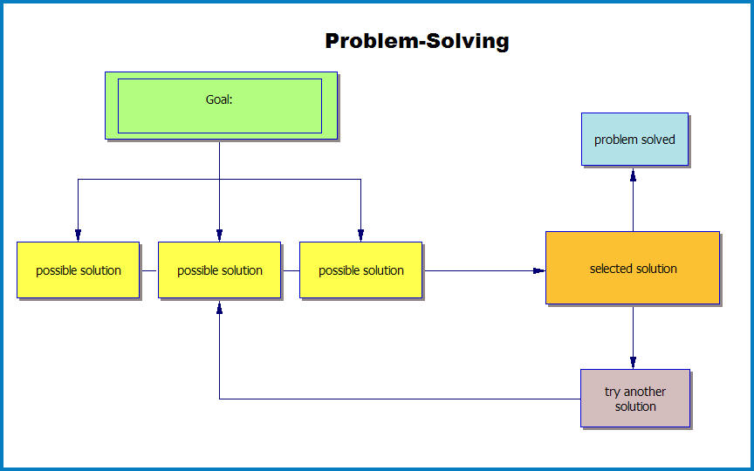

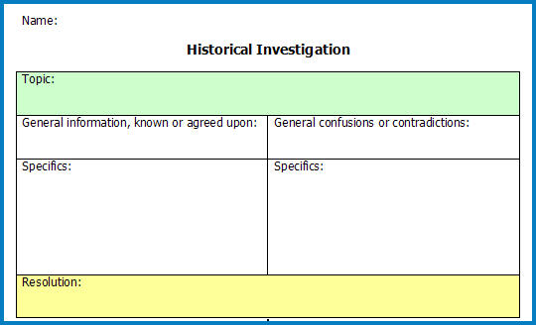

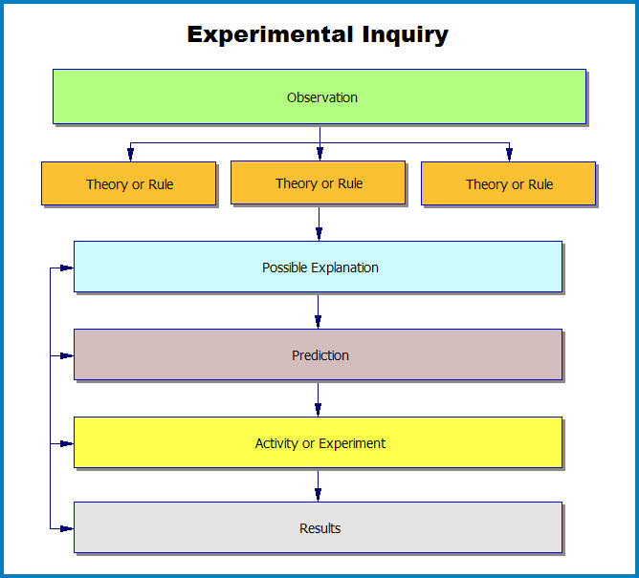
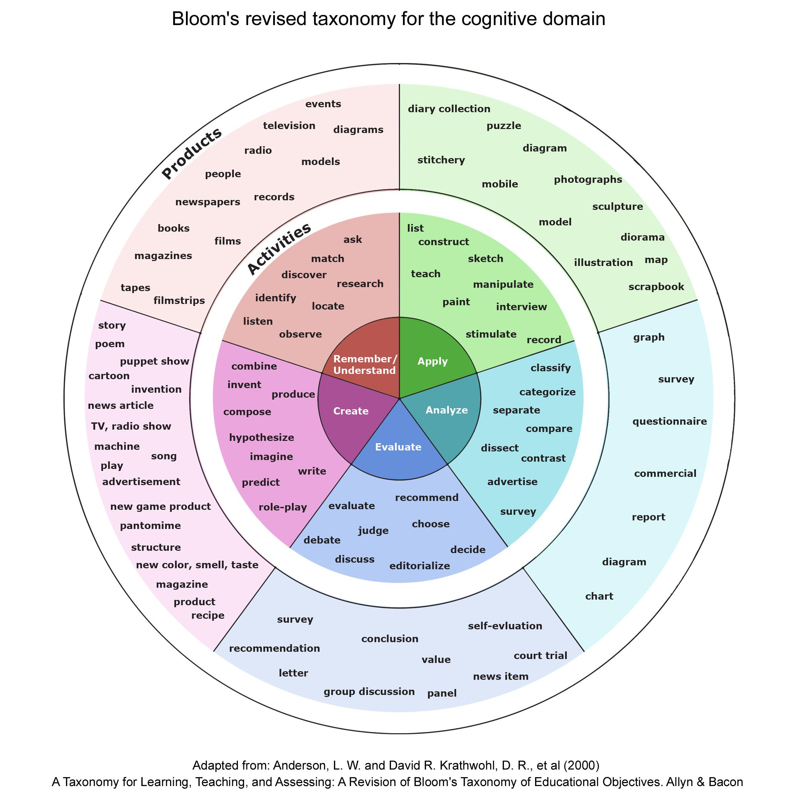

Accessed online at: http://www.heybradfords.com/moonlight/files/CV/ProfSampleFiles/CDWS/bloom_revised_taxonomy_fB1-graphic.jpg
What does Bloom’s Taxonomy look like in your classroom?

- Knowledge of terminology; specific facts; ways and means of dealing with specifics (conventions, trends and sequences, classifications and categories, criteria, methodology); universals and abstractions in a field (principles and generalizations, theories and structures): Knowledge is defined as the remembering (recalling) of appropriate, previously learned information.

defines; describes; enumerates; identifies; labels; lists; matches; names; reads; records; reproduces; selects; states; views; writes.

- Comprehension: Grasping (understanding) the meaning of informational materials.

classifies; cites; converts; describes; discusses; estimates; explains; generalizes; gives examples; illustrates; makes sense out of; paraphrases; restates (in own words); summarizes; traces; understands.

- Application: The use of previously learned information in new and concrete situations to solve problems that have single or best answers.

acts; administers; applies; articulates; assesses; charts; collects; computes; constructs; contributes; controls; demonstrates; determines; develops; discovers; establishes; extends; implements; includes; informs; instructs; operationalizes; participates; predicts; prepares; preserves; produces; projects; provides; relates; reports; shows; solves; teaches; transfers; uses; utilizes.

- Analysis: The breaking down of informational materials into their component parts, examining (and trying to understand the organizational structure of) such information to develop divergent conclusions by identifying motives or causes, making inferences, and/or finding evidence to support generalizations.

analyzes; breaks down; categorizes; compares; contrasts; correlates; diagrams; differentiates; discriminates; distinguishes; focuses; illustrates; infers; limits; outlines; points out; prioritizes; recognizes; separates; subdivides.

- Synthesis: Creatively or divergently applying prior knowledge and skills to produce a new or original whole.

adapts; anticipates; collaborates; combines; communicates; compiles; composes; creates; designs; develops; devises; expresses; facilitates; formulates; generates; hypothesizes; incorporates; individualizes; initiates; integrates; intervenes; invents; models; modifies; negotiates; plans; progresses; rearranges; reconstructs; reinforces; reorganizes; revises; structures; substitutes; validates.

- Evaluation: Judging the value of material based on personal values/opinions, resulting in an end product, with a given purpose, without real right or wrong answers.

appraises; compares & contrasts; concludes; criticizes; critiques; decides; defends; interprets; judges; justifies; reframes; supports.

Resources and References:

BOOK: Marzano, R. J., et al. (2001). Classroom Instruction that Works. Alexandria, VA: ASCD.

RESOURCES
- What Words in Classroom Instruction - free PDF download on the McREL website http://www.mcrel.org/PDF/Instruction/5992TG_What_Works.pdf
- For more diagrams and graphic organizers, visit: http://gets.gc.k12.va.us/VSTE/2008/index.htm
- “Visual Imagery – Painting Pictures in Your Head” PowerPoint: http://gets.gc.k12.va.us/VSTE/2008/5NonLinguistic_Rep/visualization/Visual_Imagery.ppt#298
- Marzano’s “Top 9” list and resources: http://edweb.tusd.k12.az.us/cfranco/marzano.htm
- Sample lesson plan template: http://www.docstoc.com/docs/7449671/CTE-Marzano-Strategy-Integrated-Activity-Lesson-Plan-Template

TECHNOLOGY
- Tech4Learning: Supporting Classroom Instruction that Worlks – technology integration tips: http://www.tech4learning.com/userfiles/file/pdfs/Resources/Tech4Learning_Supporting_Classroom_Instruction_that_Works.pdf
- PowerPoint w/online tools: http://pimarsc.pbworks.com/Marzano-Strategies-and-IDEAL
- Specific technology links:
- Identifying Similarities & Differences:
  - Inspiration & Kidspiration http://www.inspiration.com/
  - Analogies of the Day: http://www.factmonster.com/analogies/
  - Quia: http://www.quia.com/cb/7146.html
- Summarizing & Note Taking: Notestar: http://notestar.4teachers.org/
- Reinforcing Effort & Providing Recognition:
  - Certificate Maker http://www.certificatemaker.com/html/create_award.cfm
  - Voicethread http://voicethread.com/
  - Slideshare http://www.slideshare.net/
- Homework & Practice:
  - Online Stopwatch: http://www.online-stopwatch.com/
  - Homeworkopoly: http://www.teachnet.com/homeworkopoly/index.html
- Non-Linguistic Representations:
  - ReadWriteThink/Click on Student Materials: http://www.readwritethink.org/
  - Visual Thesaurus: http://www.visualthesaurus.com/
- Cooperative Learning:
  - Webquests: http://www.webquest.org
  - Wikispaces: http://www.wikispaces.com/
  - Google Docs: http://docs.google.com
- Setting Objectives & Providing Feedback:
  - Live classroom participation: http://www.polleverywhere.com/
  - Project Based Learning: http://pblchecklist.4teachers.org/
- Generating & Testing Hypothesis:
  - National Library of Virtual Manipulatives: http://nlvm.usu.edu/
  - Amusement Park Physics: http://www.learner.org/interactives/parkphysics/coaster/
- Questions, Cues and Advance Organizers:
  - KWHL Chart http://allenswanson.org/marzano/Inspiration_Templates/KWHL.gif
  - Social Bookmarking in Plain English: http://commoncraft.com/bookmarking-plain-english

